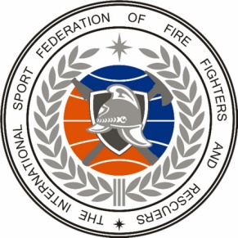 | 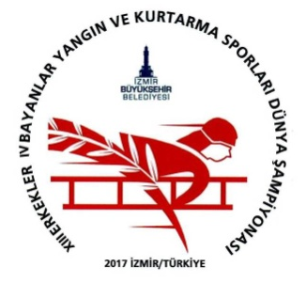  PROGRAM  Of the XIII World Championship among men and IV World Championship among women in Fire and Rescue (fire-applied) Sport «Izmir-2017»

Time | Name of event | Venue
25 September - Monday 2017
00.01-20.00 | Meeting (on schedule) and accommodation of participants | Hotel
09.00-20.00 | Accreditation and registration
18.00-21.00 | Dinner
26 September - Tuesday 2017
07.00-08.00 | Breakfast | Hotel
08.00-09.00 | Transfer to places of testing shells
09.30-13.00 | Meeting of the Credentials Committee | Kultur park
09.30-18.30 | Testing of the shells(according to the schedule) | Stadium “Ataturk”  Kultur park
13.00-14.30 | Lunch (Lunch box) | Kultur park
15.00-16.00 | Meeting representatives of the teams and Main Jury, the draw | Kultur park
18.30-19.30 | Transfer to the hotel for sports teams
19.30-22.30 | Dinner for sports teams | Hotel
16.00-16.30  16.00-19.00  20.00-23.30 | Members of GRC, heads and representatives of sports delegations:  Transfer to the start of the excursion program  Cultural program in the city Izmir  Official dinner | Konak, Agora, Karsiyaka, Asansor (lift)
27 September - Wednesday 2017
07.00-08.00 | Breakfast | Hotel
08.00-09.00 | Transfer to the competition venue
10.00-11.30 | Climbing with the hook ladder on the 2nd floor of the training tower (women) | Kultur park
11.30-14.00 | Climbing with the hook ladder on the 4th floor of the training tower (men)
12.00-14.00 | Lunch (Lunch box) | Kultur park
14.00-15.00 | Transfer to the hotel
17.00-18.00 | Transfer to the place of opening
18.00-19.00 | Preparation for Grand opening event | Kultur park
19.00-21.00 | Grand opening of the competition.  Semi-final and final races in the rise of a hook ladder  Ceremony of rewarding of winners and prize-winners | Kultur park
21.00-22.00 | Transfer to the hotel for sports teams
22.00-23.00 | Dinner for sports teams | Hotel
21.00-21.15  21.15-23.30 | Members of GRC, heads and representatives of sports delegations:  Transfer to the venue of the official meeting  Official reception from the Mayor of the city Izmir Aziz Kocaoglu | Uckuyular Korfez Boat
23.30-00.30 | Transfer to the hotel
28 September - Thursday 2017
07.00-08.00 | Breakfast | Hotel
08.00-09.00 | Transfer to the stadium “Ataturk”
10.00-11.10 | Overcoming the 100-meter obstacle (women) | Stadium “Ataturk”
11.20-11.50 | Semi-final and final races (women)
12.00-13.30 | Lunch (Lunch box)
14.00-16.30 | Overcoming the 100-meter obstacle (men)
16.50-17.30 | Semi-final and final races (men)
18.00-19.00 | Transfer to the hotel
19.30-21.00 | Dinner | Hotel
29 September - Friday 2017
07.00-08.00 | Breakfast | Hotel
08.00-09.00 | Transfer to the stadium “Ataturk”
10.30-12.00 | Fire Race-Relay 4 х100 m (women) | Stadium “Ataturk”
12.00-13.30 | Lunch (Lunch box)
14.00-16.30 | Fire Race-Relay 4 х100 m (men)
17.00-18.00 | Transfer to the hotel
19.30-21.00 | Dinner | Hotel
30 September - Saturday 2017
07.00-08.00 | Breakfast | Hotel
08.00-09.00 | Transfer to the stadium “Ataturk”
09.00-10.00 | Preparing for combat deployment and delivery of fire and technical equipment | Stadium “Ataturk”
10.00-12.00 | Combat deployment ( women)
12.00-14.00 | Lunch (Lunch box)
12.00-15.00 | Combat deployment ( men)
15.00-16.00 | Transfer to the hotel
18.30-19.30 | Transfer to the venue of the closing ceremony
20.00-23.30 | The closing ceremony  The ceremony of awarding the winners  Gala dinner and official reception from the Mayor of the city Izmir Aziz Kocaoglu | Restaurant  Havagazi Fabric
23.30-00.30 | Transfer to the hotel
01 September - Sunday 2017
06.00-08.00 | Breakfast | Hotel
08.00 | Departure of delegations

